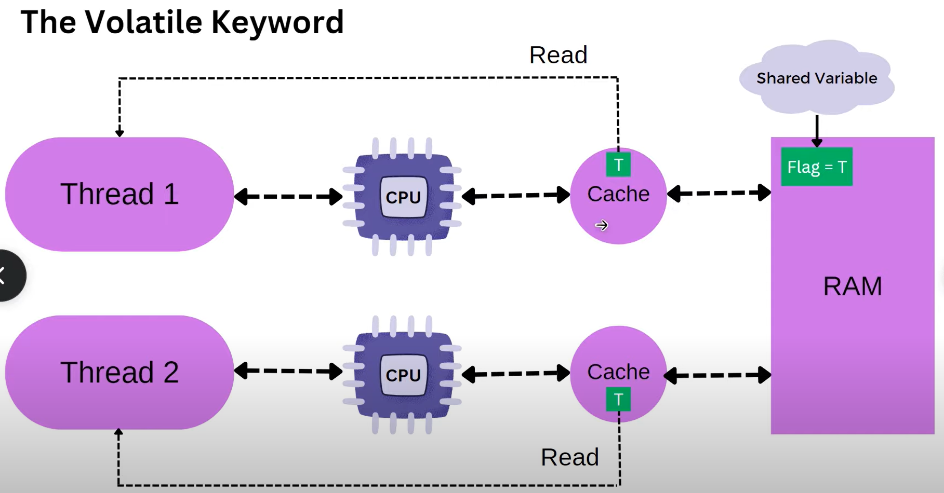

3.Now problem might happen is, if one thread changes the values of cache to false, it won’t update directly into the RAM. First it updates in its local cache

4.when other thread which is accessing the cache that will be TRUE only, because it is not updated in local cache, as well as in the main memory it will be true only

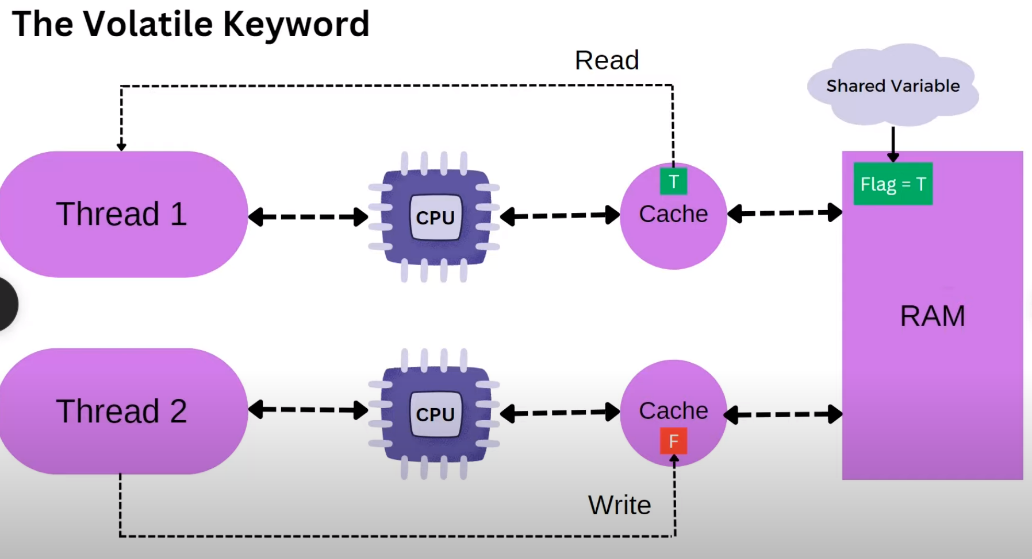

After some time, the cache values false will update in the main memory (Ram) as false

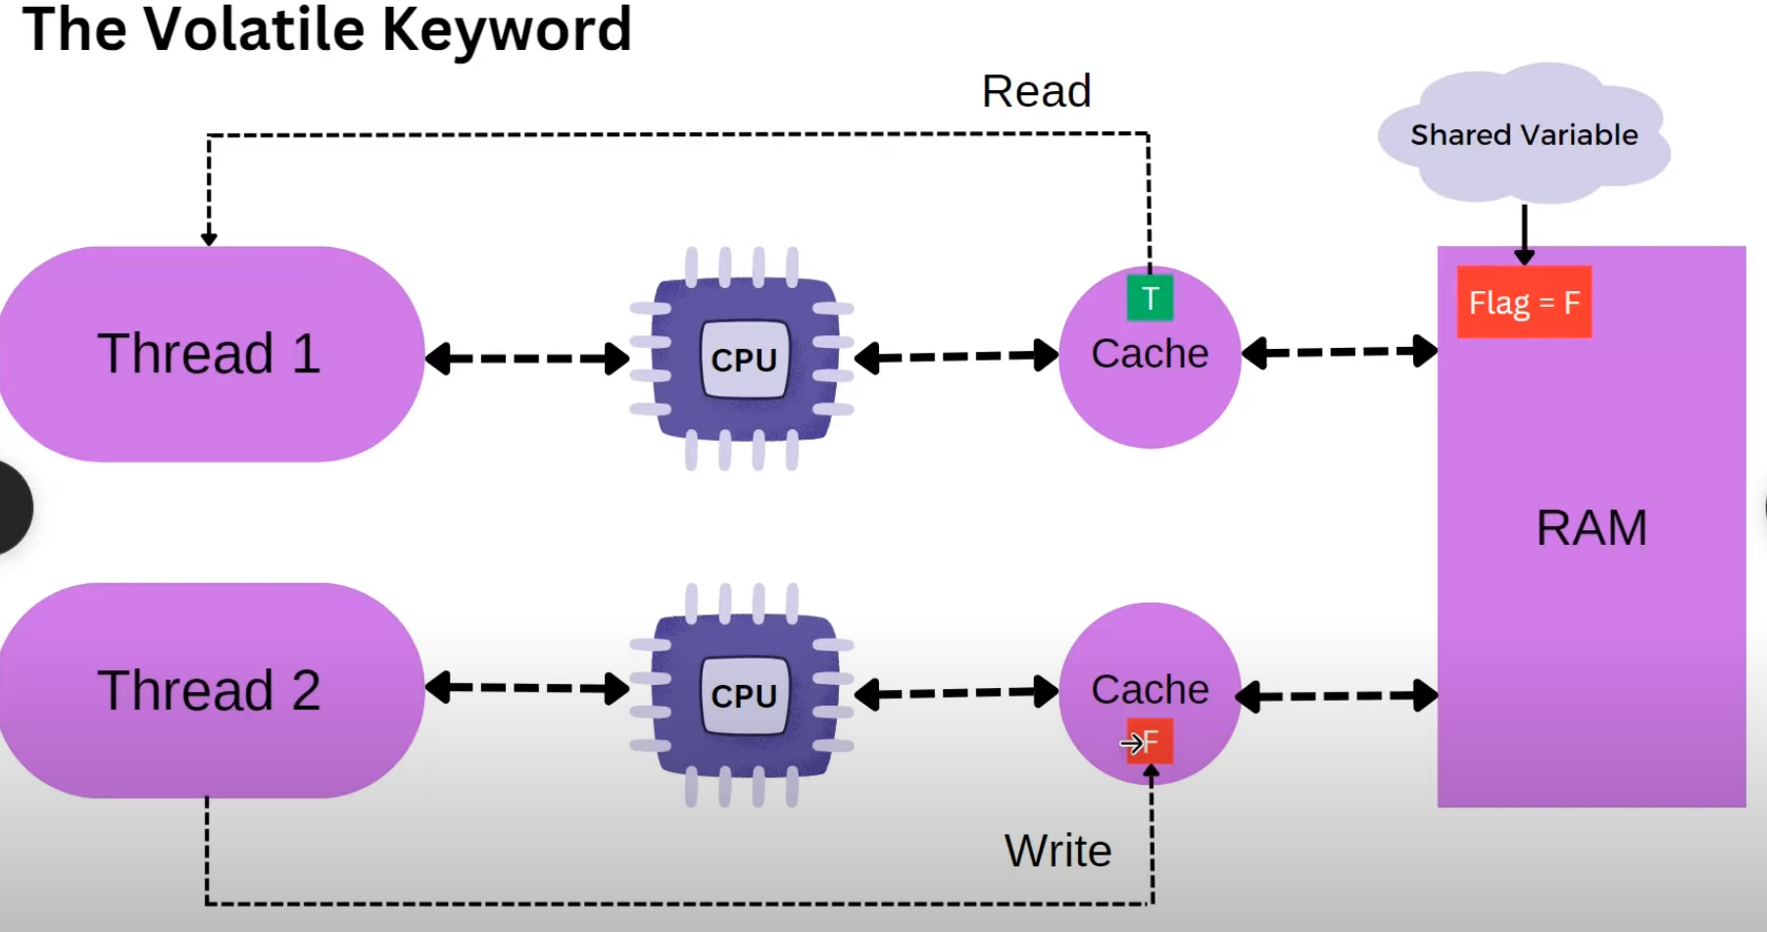

Volatile: - 1.now we declare that shared variable as volatile

2.From now onwards its word read the data from cache, it read the shared variable from the main memory only (RAM);

3.If thread two changes the state of the volatile shared variable them then one will have access to it right

